**Get Unique Values from a List Using Set Method**

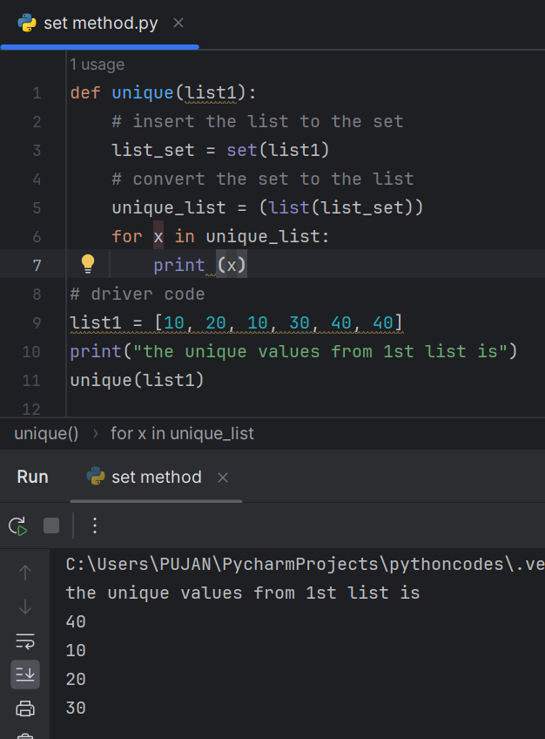

**Get Unique Values From a List in Python Using reduce() function**

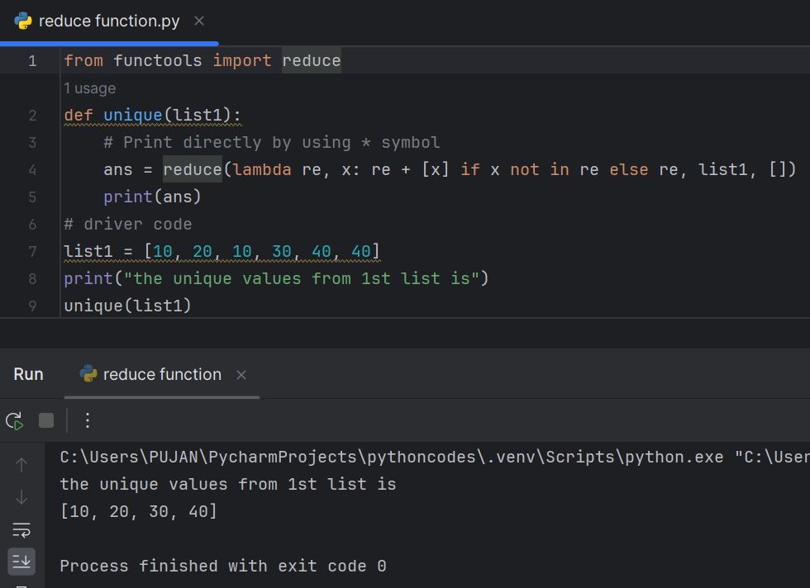

**Get Unique Values From a List in Python Using Operator.countOf() method**

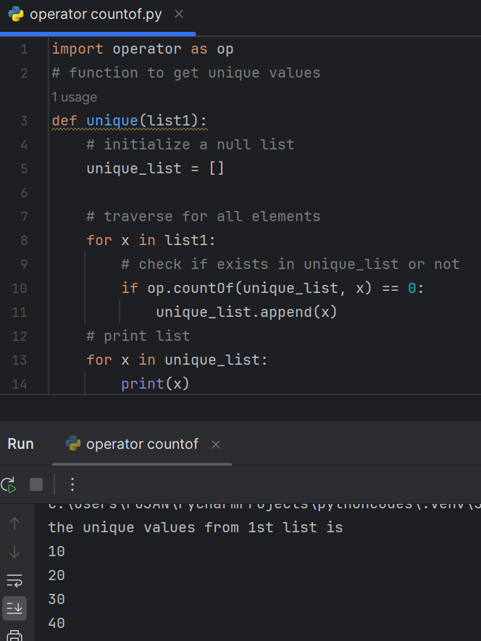

**Get Unique Values From a List in Python Using pandas module**

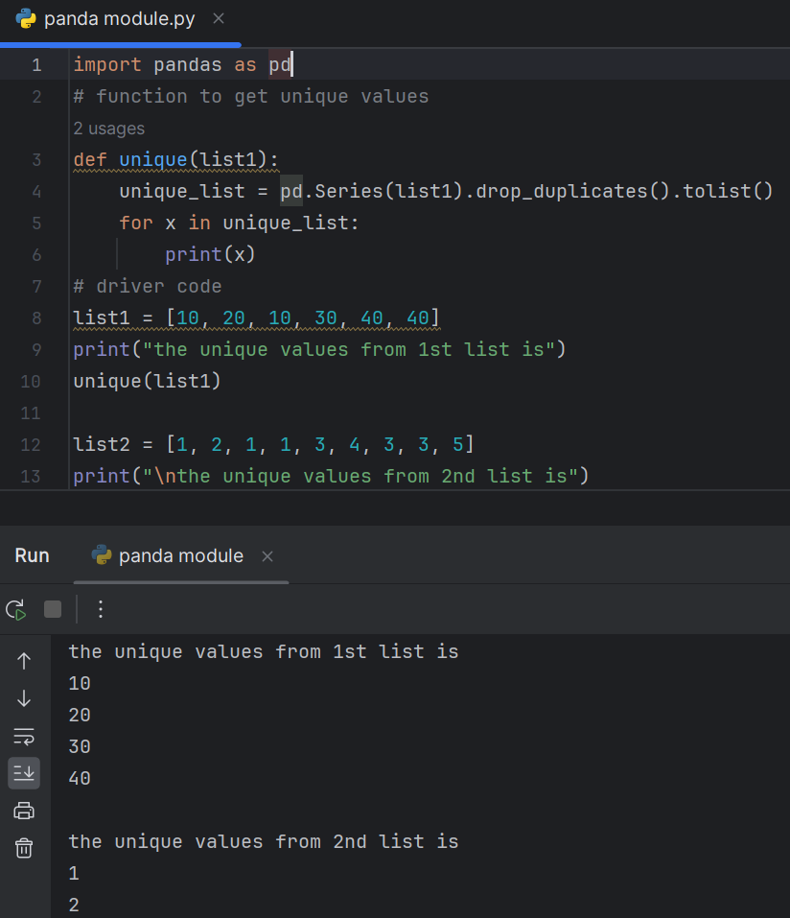

**Get Unique Values From a List Using numpy.unique**

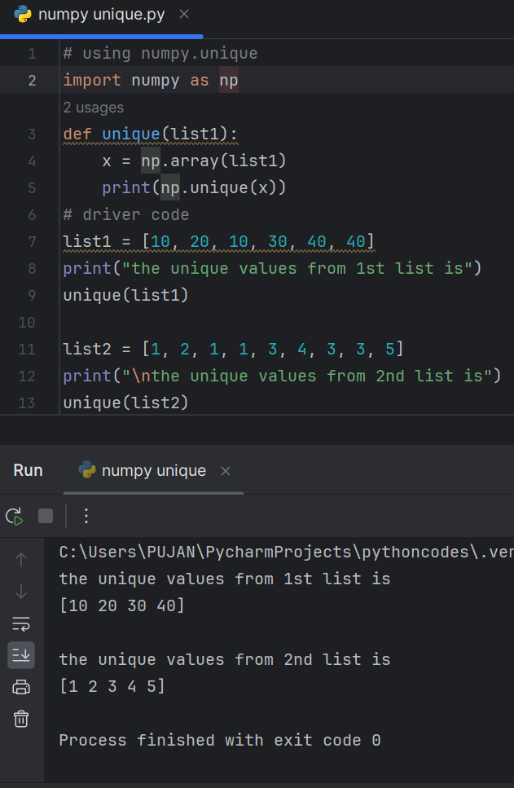

**Get Unique Values From a List in Python Using collections.Counter()**

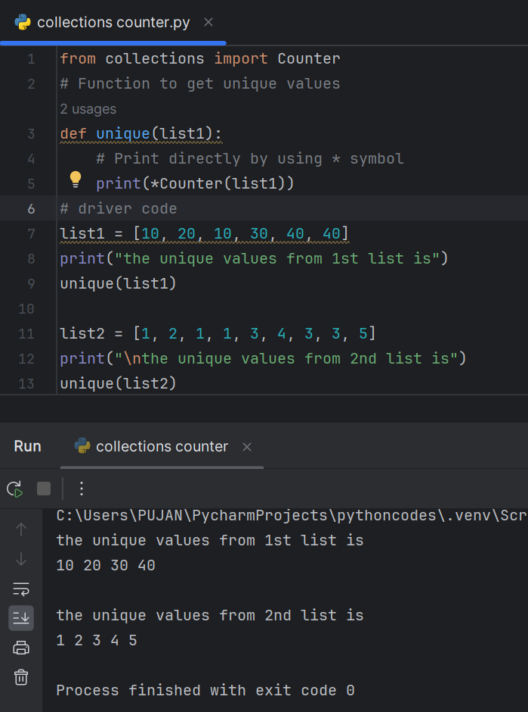

**Get Unique Values From a List Using dict.fromkeys()**

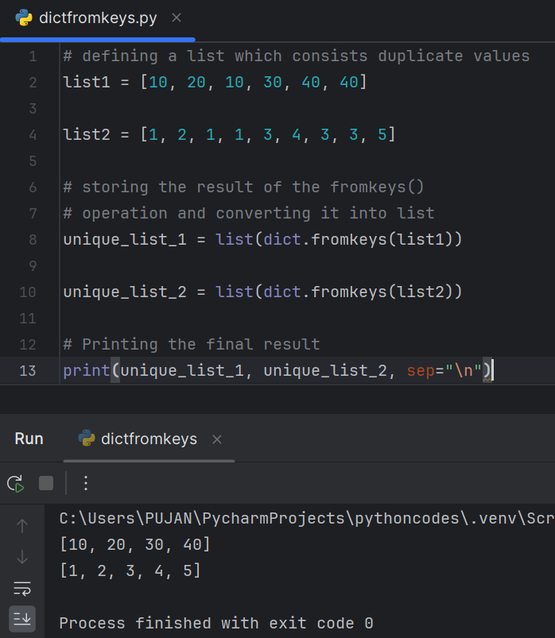

Sort Python lists using key in Python

Sorted()

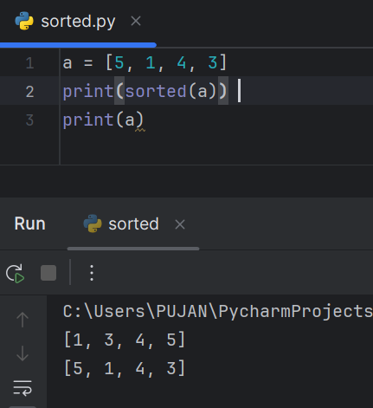

The sorted() optional argument reverse=True

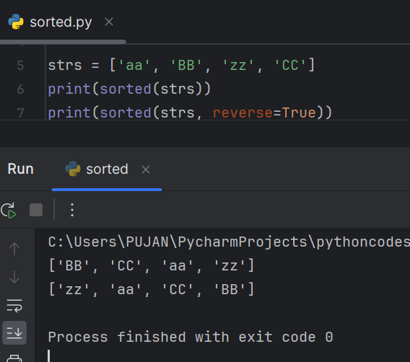

Custom Sorting With key=

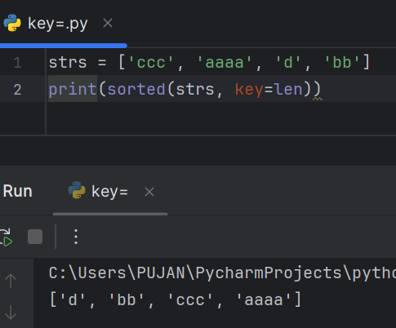

**Convert JSON String to Dictionary Python**

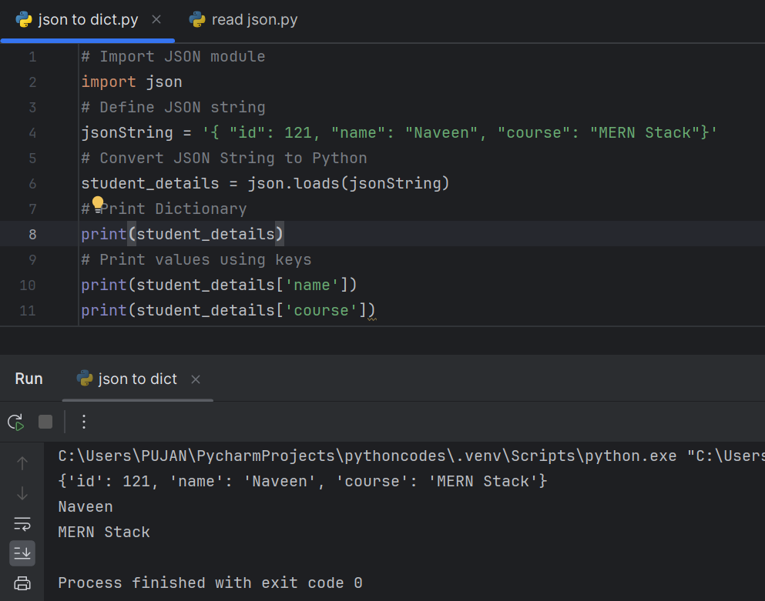

**Convert JSON String to Dictionary in Python**

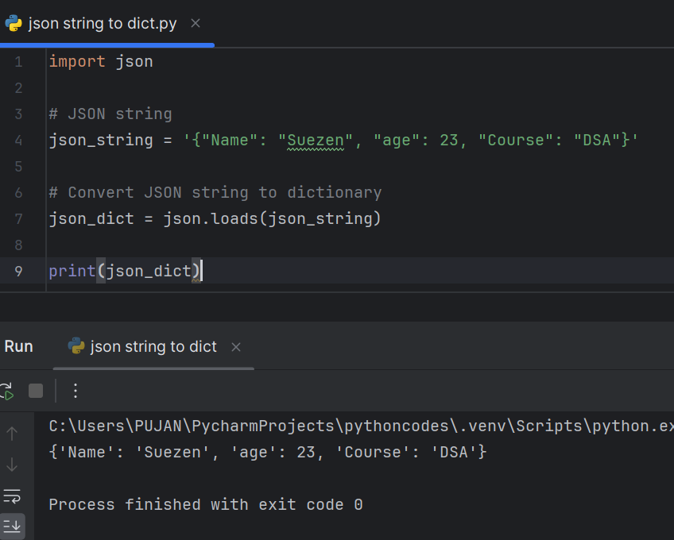

**Convert JSON File to Python Object**

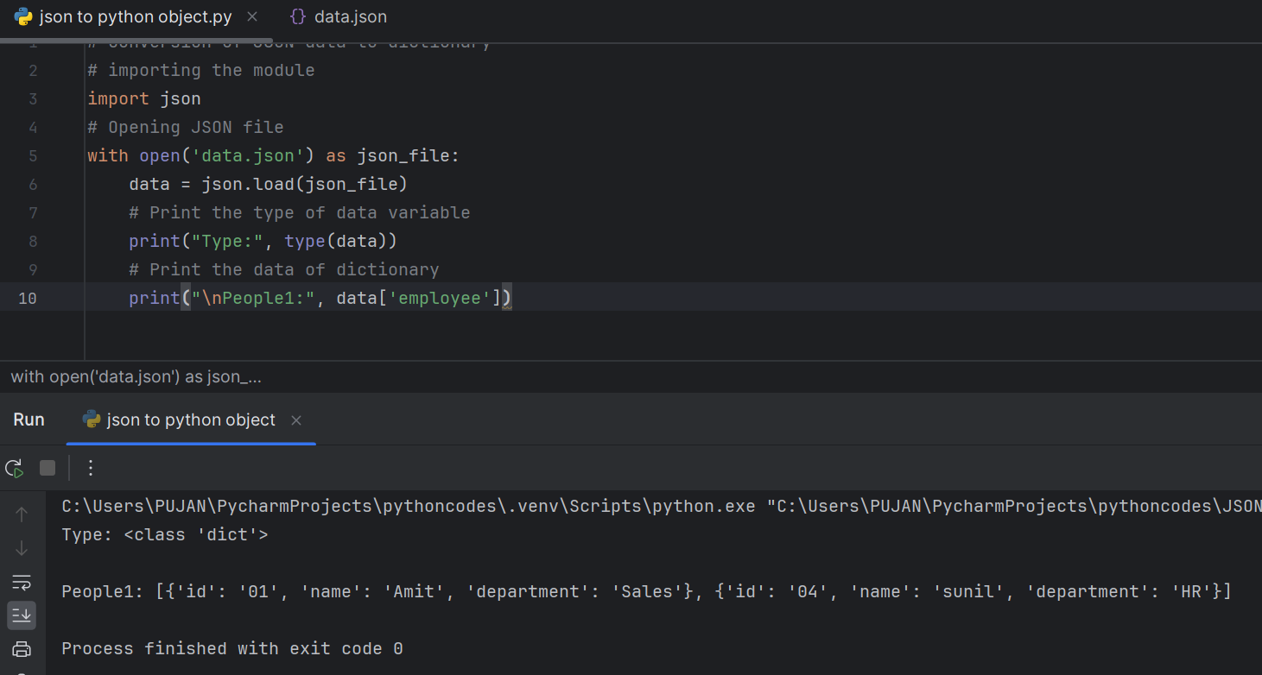

**Convert Nested JSON Object to Dictionary**

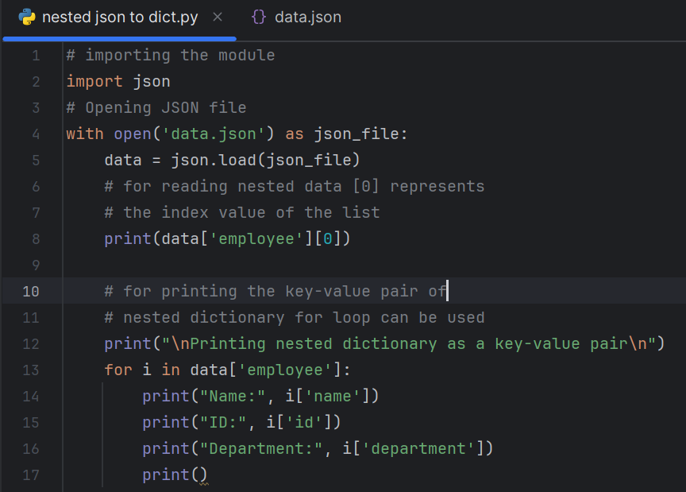

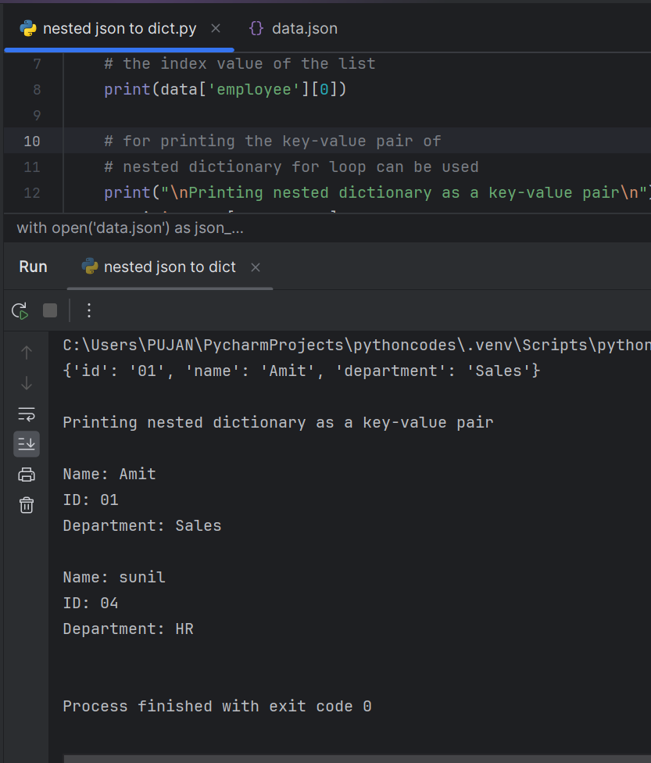

**Python Parse JSON String**

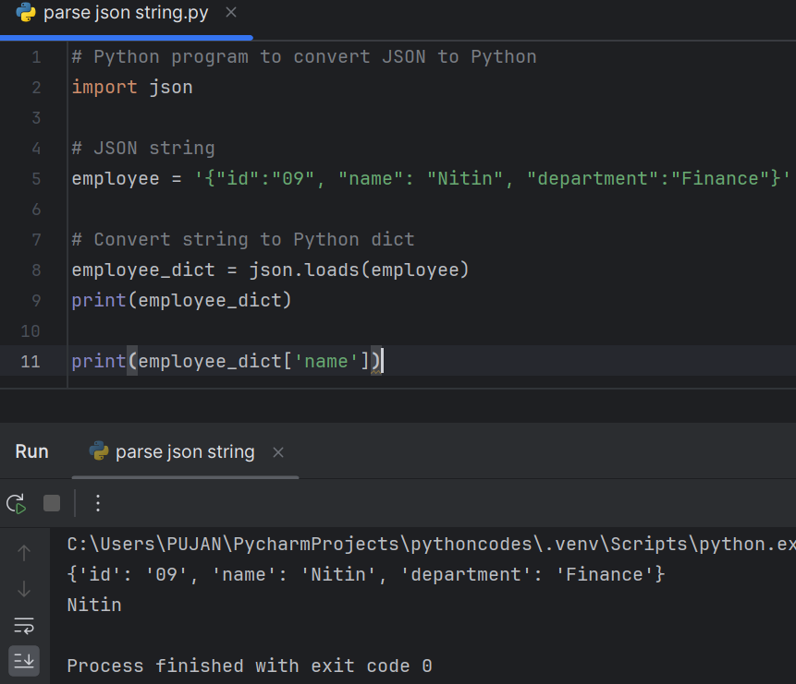

**Read, Write and Parse JSON using Python**

**Python read JSON file**

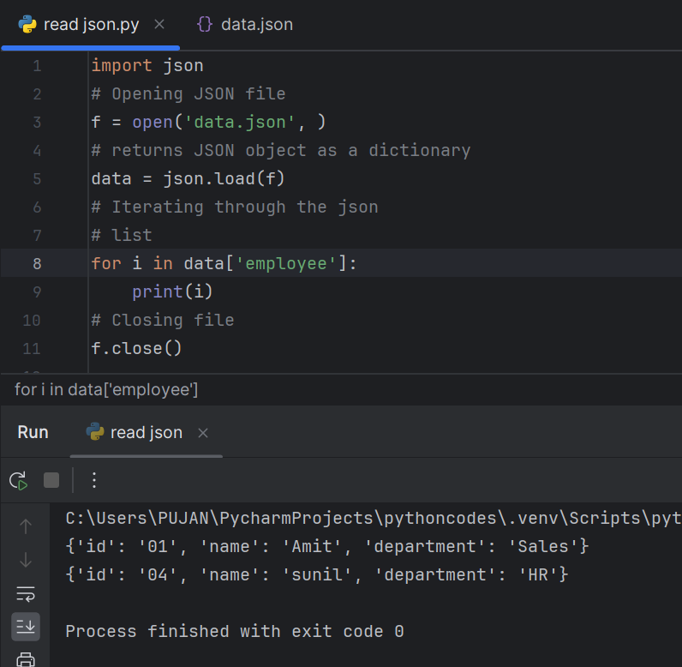

**Convert Python Dict to JSON**

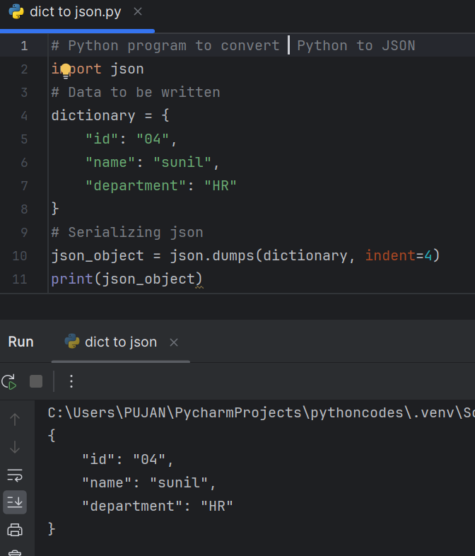

**Writing JSON to a file in Python**

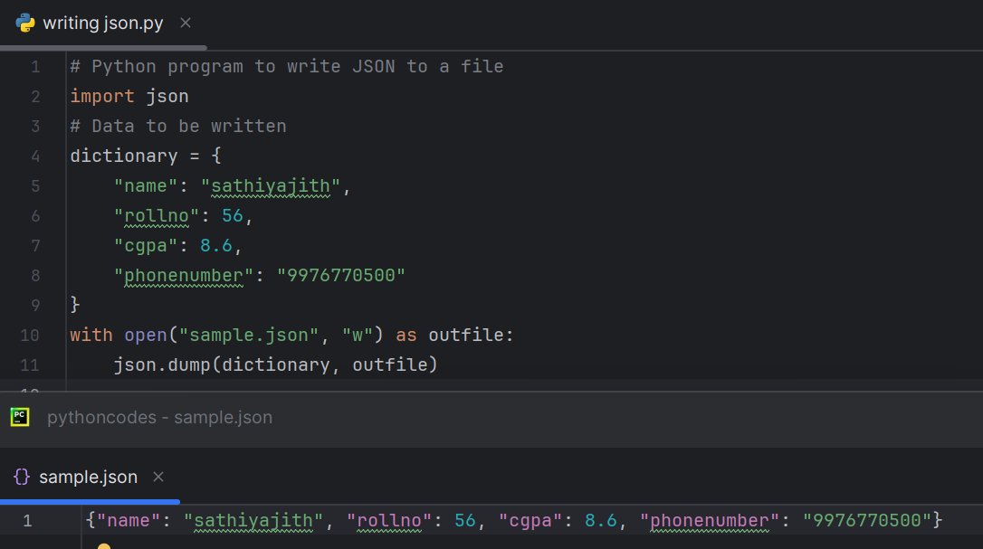

**Python Pretty Print JSON**

